Project Design Phase-II

Data Flow Diagram & User Stories

|  |  |
| --- | --- |
| Date | 03 October 2022 |
| Team ID | PNT2022TMID40672 |
| Project Name | **Project - Airlines Data Analytics for Avaition Industry** |
| Maximum Marks | 4 Marks |

# Data Flow Diagram:

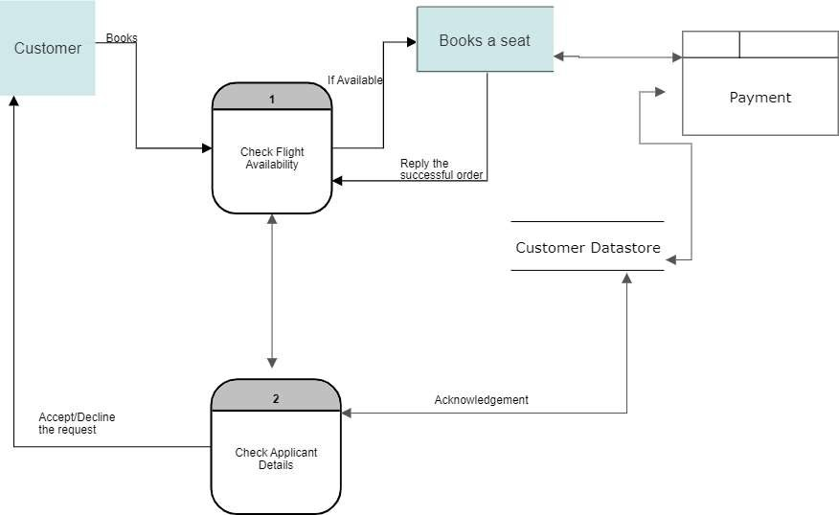A Data Flow Diagram (DFD) is a traditional visual representation of the information flows within a system. A neat and clear DFD can depict the right amount of the system requirement graphically. It shows how data enters and leaves the system, what changes the information, and where data is stored.

Example: DFD Level 0 (Industry Standard)

# User Stories

Use the below template to list all the user stories for the product.

|  |  |  |  |  |  |  |
| --- | --- | --- | --- | --- | --- | --- |
| **User Type** | **Functional**  **Requirement**  **(Epic)** | **User Story Number** | **User Story / Task** | **Acceptance criteria** | **Priority** | **Release** |
| Customer (Web user) | Registration | USN-1 | As a user, I can register for the application by  entering my email, password, and confirming my password. | I can access my account / dashboard | High | Sprint-1 |
|  |  | USN-2 | As a user, I will receive confirmation email  once I have registered for the application | I can receive confirmation  email & click confirm | High | Sprint-1 |
|  |  | USN-3 | As a user, I can register for the application through Gmail. |  | Medium | Sprint-1 |
|  | Login | USN-4 | As a user, I can log into the application by entering email & password. | I can get to access my web portal | High | Sprint-1 |
|  | Dashboard | USN-5 | As a user, I can get to know what my dashboard consists of. | I can my details of my registration. | Low | Sprint-2 |
| Customer Care Executive | Organization | USN-6 | The organization which owns this airplane analysis system will enable the option to customers to reach out the organization if   * they have any problem with the organization’s system of customer interaction or * airplane issues- delay, landing in a different location | The customer care workers will help out the customers in trouble. | High | Sprint-1 |
| Administrator | Administration | USN-7 | The organization takes in-charge of the administrative policies of different departments like:   * registration * flight booking * delay visualization * generation of delay report | As an administrator, confirmation of user while registration is done. | High | Sprint-1 |